**RECO: A lost or stolen property recovery system**

**Student No: 112296**

**Group: 4C**

**An Information System Project documentation submitted to the Faculty of School of Computing and Engineering Science in partial fulfilment of the requirements for the award of the bachelor’s degree in Business Information Technology of Strathmore University**

**Date of Submission: January 2022**

Declaration

I declare that this work has not been previously submitted and approved for the award of a degree by this or any other University. To the best of my knowledge and belief, the research document contains no material previously published or written by another person except where due reference is made in the research proposal itself.

Student Signature:

Sign: _____________________________ Date: ____________________________

Supervisor’s Name:

**Approval**

The Information System Project 2 documentation of 8909 was reviewed and approved (for examination) by: Mr Daniel Kurui

Supervisor’s signature:

………………………………….………….. [Signature]

31st Jan 2022

………………………………….………….. [Date

Abstract

Security is one of the post important things in a country. This is both the security of an individual and the security of an individual’s property, and as long as man is to error it is possible for an individual’s property to get lost. Based on Kenyan survey that was conducted years back it indicated that 18.4% of the crimes committed involved in theft this means taking of someone’s property without their knowledge or authorization. (kenya-police, 2018). Someone who has lost something through theft or misplacement they are all in need of the same service which is finding their lost property. The project focus on providing a platform that helps in recovery of lost items but also a system that helps in solving several problems. There is the problem of mistaken handling of stolen goods, this can be a problem to both secondhand buyers and even people who provide repair services as one will come in pretenders that the item belongs to them but in the real sense it was stolen. In which most all these problems are solved through public involvement in being whistle blower when they are provided with something stolen or when they find something that was lost.

This project came up with a system that has enables users to upload a picture, description, and a serial code of the item that they have lost or have gotten stolen, in which it has also provide a search bar that has been linked to the found items so as to know if your item has been found or not. It also has a conversation tab that has link the person who lost their items with those who found it. With instructions on how to safely retrieve your item from the person possessing it.

The system has been developed through the use of prototyping methodology which helps in error handling. The tools used in the development are virtual studio code in where the script has be written html and CSS was used on the front end. On the back end of the system php, JavaScript and MySQL has acted as the database.

Key words: User, lost, stolen, found items, stolen items report, search bar, safely retrieval.

**Table of Contents**

Declaration ii

Abstract iii

List of Figures iii

List of Tables iv

List Of Abbreviations v

Chapter 1: Introduction 1

1.1 Background 1

1.2 Problem statement 2

1.3 Aim 2

1.4 Specific Objective 2

1.5 Justification of the study 3

1.6 Scope and limitation 3

Chapter 2: Literature Review 4

2.1 Introduction 4

2.1.1 A description of current processes of finding lost or stolen items. 4

2.1.2 Challenges faced by current processes in finding lost or stolen items. 4

2.2 A Review of the existing lost and found system that is web based. 5

2.2.1 Lost & Found Centre 5

2.2.2 Find My Device 6

2.2.3 Find My Lost 7

2.2.4 ILost 8

2.3 Gaps in existing systems 9

2.4 Conclusion 10

2.5 Conceptual Framework 10

Chapter 3: System Development Methodology 12

3.1 Introduction 12

3.2 Prototype Methodology 12

3.2.1 Identifying the Problem 13

3.2.2 Develop Prototype 13

3.2.3 Implement and Use Prototype 13

3.2.4 Rehearse and Enhance Prototype 13

3.2.5 Convert to operational System 13

3.3 Justification of Methodology 13

3.4 Object Oriented Analysis and Design 13

3.4.1 Functional Requirement 14

3.4.2 Non-Functional Requirements 15

3.5 Design 15

3.6 System Development Tools and Techniques 15

3.6.1 HTML 16

3.6.2 CSS 16

3.6.3 PHP 16

3.6.4 MySQL 16

3.6.5 XAMPP 16

3.6.6 JavaScript 16

3.6.7 STARUML 16

3.7 System Testing 16

3.7.1 Functional Testing 17

3.8 Domain of execution 17

3.9 Milestones and Deliverables 17

3.9.1 Administrator module 17

3.9.2 User module 17

Chapter 4: System Analysis and Design Description 18

4.1 Introduction 18

4.2 Requirements Gathering 18

4.2.1 Data collection 18

4.2.2 Literature review 18

4.2.3 Questionnaires 18

4.2.4 Interviews 19

4.2.5 Focus Group Interviews 19

4.2.6 Structured Interviews 19

4.3 System Requirements 19

4.3.1 Functional Requirements 20

4.3.2 Non-Functional Requirements 20

4.4 System Architecture 21

4.5 Analysis 22

4.6 Design 22

4.6.1 Use case diagram 23

4.6.2 Class Diagram 24

4.6.3 Entity Relation Diagram 26

4.6.4 Database schema 27

Chapter 5: System Implementation and Testing 28

5.1 Introduction 28

5.2 System Implementation 28

5.3 System testing 28

5.3.1 Functionality testing 29

5.3.2 Usability testing 29

5.3.3 Unit testing 29

Chapter 6: Discussion, conclusion and recommendation 30

6.1 Introduction 30

6.2 Discussion 30

6.3 Conclusion 30

6.4 Recommendation 31

6.5 Future Work 31

Reference 32

Appendix 35

Appendix A: Gantt chart 35

Appendix B: Data collection 36

Appendix C: Interesting Code 37

Appendix D: User Manual 39

List of Figures

Figure 2.1: Lost & Found Centre 6

Figure 2.2: Find My Device 7

Figure 2.3: Find My Lost website 8

Figure 2.4: ILost & found website. 9

Figure 2.5: Conceptual Framework 11

Figure 3.1 Prototype Methodology 12

Figure 4.1: System Architecture 22

Figure 4.2: The use case diagram 23

Figure 4.3: Sequence Diagram 24

Figure 4.4: Class Diagram 25

Figure 4.5:Entity relation diagram 26

Figure 4.6: Database Schema 27

Figure 6.1: Gantt chart 35

Figure 6.2: Pdf converter script 37

Figure 6.3:Search and filter script 38

Figure 6.4:Signup Form 39

Figure 6.5:Login Form 40

Figure 6.6: Landing page 41

Figure 6.7:Admin Panel 41

Figure 6.8:Found Items Form 42

Figure 6.9:Lost items 43

Figure 6.10:Display of all lost and found items 43

Figure 6.11:PDF converter of reports 44

Figure 6.12:Feedback(chat box) 45

List of Tables

Table 4.1: Functional Requirements 20

Table 4.2:Non-Functional Requirements 21

****List Of Abbreviations****

**LFC -- Lost & Found Center**

HTML – Hyper Text Makeup Language

PHP – Personal Home Page

SQL – Structure Query Language

XAMPP – Cross-Platform Apache MySQL PHP Perl

# Introduction

## Background

As long as theft is an issue, and man is to error there will always be a case of lost property. As indicated in the Kenya annual statistics crime report of 2018 states that 18.4% of the crime committed in Kenya are robbery and theft which we know this involves taking of people’s properties. (kenya-police, 2018). If we ensure that we have a way of limiting the buying of stolen items and finding stolen items, this will greatly reduce the crime rate in Kenya that involves theft. Although it is hard eliminating crime the thing to do is being responsible and pointing out stolen properties in order to curb crime rate in our lovely country Kenya.

In countries like Japan, they use a lost and found system which has eased the process of finding lost items and stolen. In a Documentary (Story, 2020) and in an article written a while back Japan is claimed to be one of the best countries when it comes to finding lost items. In the huge city of Tokyo nearly 4 million items were recovered in the year 2017 which included valuable items such as smartphones which some were found to be of visitors that toured the area. In Japan, their lost and found are usually stored in the lost and found department which one can go check if his/her lost item is in the building. This system in Japan has really helped as one feels at ease knowing his/her lost item is in one of the lost and found stores ready to be unites with the owner. (Hornyak, 2020).

For instance, you have lost an Item, or the item has been stolen the only way of tracing it currently it is through googles find my device in which most of the cases we have seen it not working as most phones when turned off and formatted they are untraceable hence giving it the ability to end up on someone hands as a buyer. Having a place that you cannot put it to the public to avoid someone from purchasing your stolen property is really frustrating as the possibility of you finding it is low. Currently we even see it hard for people offering repair services as some times they are told to asked to offer device formatting services in which due to lack of proper ways of ensuring that the device that they are formatting is not stolen this puts them in a great risk of handling stolen property which might lead to their conviction.

## Problem statement

Mistakenly Handling of stolen property is a big a criminal offence in Kenya which is punishable with a maximum imprisonment of fourteen years as indicated in section 322 of the Kenyan law (Kamau, 2018). This punishment can be avoided by knowing if the product being sold or given to you is recorded as stolen or missing. Identification of legit secondhand product is also a problem as currently people only rely on the basic signs of knowing a product is stolen but no actual platform to search if a product is stolen as indicated by Jess Bolluyt article (Bolluyt, 2016). Stopping the finance of criminals through the secondhand and refurbished as it is a well-known source of income for criminals (Sutton, 2020). Locating the owner of a misplaced product. Recovery of stolen items and identification of the item’s owner. In Kenya lots of people have fallen victims of theft and misplacement of property which has been very hard when it comes to retrieving or even securing their property back.

If there was a system that could enable the community to post items that they have been found lying around or even search if a product they are about to purchase was stolen, then this system could be of great use in solving the lost and stolen recovery process.

## Aim

The aim was to build a system that would help civilians post about their stolen or misplaced items, display the missing or stolen item, whistle blow on items that they were being sold too but have a misplaced or stolen record, provide an online reference to identify if the product they are purchasing is stolen and provide information of the person who misplaced the found item or item that was initially stolen.

## Specific Objective

1. To critique the current techniques of recovering lost or stolen items.
2. To investigate the existing recovery systems being used to help users retrieve back their lost property or communicate about a lost property they have found.
3. To develop a web application system that will facilitate the interaction of the users with other users or users with the system in the aim of recovering of lost or stolen items.
4. To test and evaluate the developed system.

## Justification of the study

In our modern days crime has become an emerging issue in our society and it has become one of the hardest things to solve in our society the Kenya police has tried to curb the crime, but it still manages to grow rapidly in the societies of today, with the help of technology this system has provide a platform that has enable people to verify the product they are buying was stolen. The system has also enabled owners of misplaced or stole properties to be identified as we have seen from the previous police raids the products found are usually displayed hence the police do not have an actual place to search the product found belong to who. It has also helped those whose products have gone missing to have a platform to raise their problem in home the item will be recovered. The system is reducing crime by providing people a place to confirm if something was stolen hence preventing the mistakenly handling of stolen property.

## Scope and limitation

The system has provided information of products that are stolen or misplaced. It has also provided a platform that enables people to have a conversation and plan on how to retrieve their found items. The system also provides a search bar that enables people to search on their lost products on the lost and found catalogue.

The system needs an internet connection. It only contains items that are unique identifier. As it has provided a communication platform to communicate with the person having your lost product and provide you with information on how to meet someone on a secure place but does not provide a secure place. It is only based in Kenya based on the currently available resources. The users might not get the response they require, or it might take time as most of the response are based on the information provided by the people. Hence, this does not guarantee the retrieval of the lost or stolen property.

# Literature Review

## Introduction

This chapter reviews the existing websites and the challenges they face. It also highlights the challenges encountered in the current systems, other systems related to finding lost or stolen items. It finally depicts various technologies used in Web application development.

### A description of current processes of finding lost or stolen items.

The current process in Kenya of finding your lost or stolen item is by reporting the incidence to the police station. Which is usually so hard for your item to be located as they get so many stolen items or misplaced items in a day that it overwhelms them because they are limited when it comes to their manpower. The other alternative of finding lost items in Kenya is by using the lost and found item in which based on their system we find it having some links challenges and it is limited as the manpower is based on the organization staff. (karani, 2019). The other process being used in Kenya when it comes to lost and found we find most people see Kenya displaying e.g., the lost identifications card that they have found on a wall in their shop or even other stick it on an open notice board in hope the person who has lost their item might stumble upon it works if the person back tracks their steps. People also use system like find my devices in locating their devices this works by showing you your device location if your device is still on it works well when the device is lost rather than stolen.

### Challenges faced by current processes in finding lost or stolen items.

Currently there are several challenges being faced by the different processes in retrieving your lost or stolen items. The current process of reporting your lost or stolen items to the police we find in most cases it is usually hard to retrieve your item as they are usually overwhelmed by so many reports hence, they tend to priorities the items that were used on a crime situation. They also face the problem of limited stuff as going to retrieve every one’s product my seem almost impossible. When it comes to the Lost & Found Centre (karani, 2019) it faces several challenges, we find it being limited to in sending an email to the organization and being able to subscribe. They only get to you if their staff manages to get the item that you are looking for. This means that the system is limited due to the centralized system. As for the posting of the identification card on notice board in most cases it is hard for one to properly back track as the person might have used a public means of transport and the probability of getting back on the same vehicle is low.

## A Review of the existing lost and found system that is web based.

These are systems that are used in providing information on lost items. The systems have been implemented to the public trying to curb the problem encountered during the tracing of lost or stolen items. These systems include Lost & Found Centre (karani, 2019), FaundIT (Casper, 2020) which is still a demo, Troov a web-based system (SAS, 2020) Find My Device (Chris, 2019), ILost (Bayard, 2015) and Find My Lost (Merlot, 2016)

### Lost & Found Centre

The Lost & Found Centre website is a platform that provides information of what the organization does to find your lost items. The details contained in the LFC are their contact number, numerical information of the total items they have found which is divided into various categories these are passport, title deeds identification cards etc. They also provide information on how you can report your stolen items in which it is indicated it is done through an application. They do provide you with an audio that communicates to you about the work of the organization.

The advantage of the system is that they have outlined their telephone number and email address hence you have a way of getting to communicate with them. They also provide information about their app in which it can be used to report. They also give you a choice of subscribing to their newsletter which gives you information about their resent finds. On addition we see them working closely with the police officer in the process of finding the lost items. (karani, 2019)

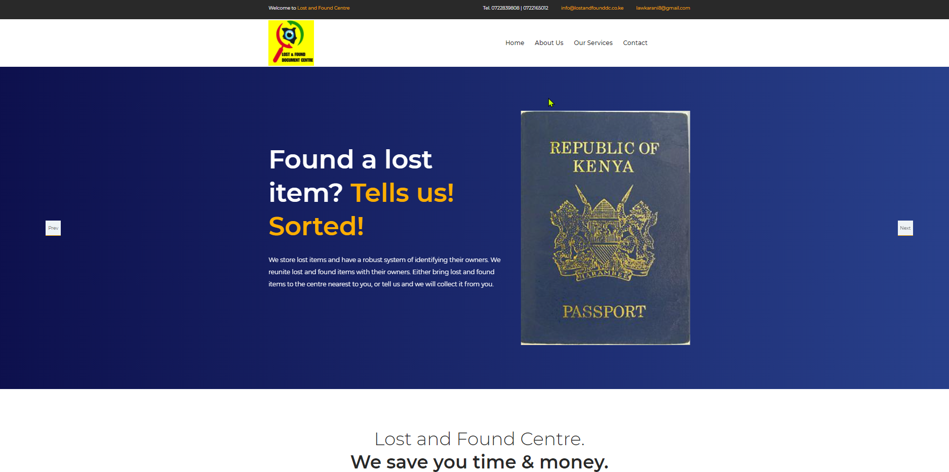

Figure .: Lost & Found Centre

(karani, 2019)

### Find My Device

This is a web-based system that was developed by Google platform in which its aim is to help individual in finding their lost devices or stolen devices. It works by giving you a platform that allows you to login with the same email address that the lost or stolen device uses which in turn it provides you with the information of the device. This system works by providing you with the geographical location of your devices and the ability to lock or erase all content if it contains crucial information.

The system packs a sleeve of advantages these include the ability for an individual to allocate their phone due to the geographical representation. It also has a play sound future that enables you to ring the phone if you are within the location radius hence providing you with that exact position. The secure device helps an individual to lock the device hence preventing anyone phone tampering with the device. It also comes with the Erase device feature that allows you to delete all information that is in the device if it is sensitive. (Chris, 2019)

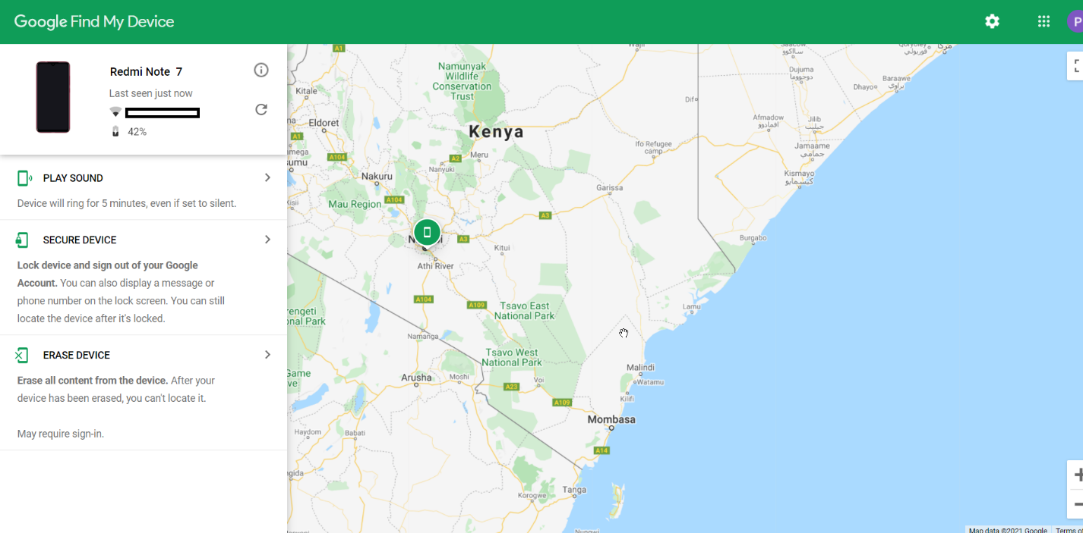

Figure .: Find My Device

(Chris, 2019)

### Find My Lost

This is a web-based system that developed in order to help people find their lost properties. What the system does it provide you with a platform that enables you to login to the system. You are then provided with two options reporting an item that you have found or reporting an item that you have lost. In selecting I have found a lost item you are greeted with form in which you are required to fill the item that you have lost, the category of the item and where did you find it last. You then processed to the next option in which you enter the picture of the item and the description of the item how the item is to be delivered and finally a reward option. In the lost an Item section you enter what you have lost brand of the item you have lost and the colour of the item and where you last lost the item finally you conclude by searching. (Merlot, 2016)

The system has several advantages, and we see on of the advantages it is that it enables you to search for your lost item in the search bar. We see the system also allowing the people who have found a lost item to make a report by filling a form that collects description of item found the category in which the item belongs to, the date in which the item was found, the image of the item and where it found and also an option on how to deliver the item found. (Merlot, 2016)

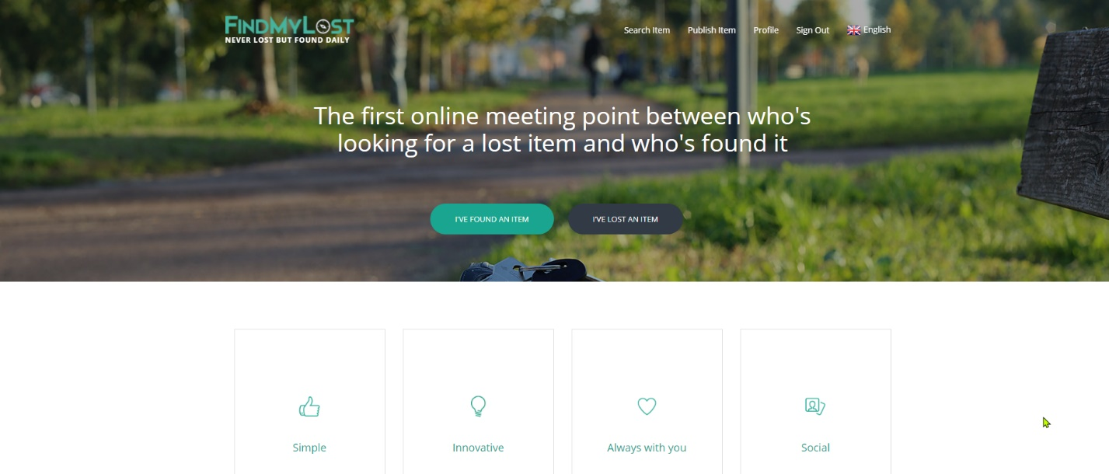

Figure .: Find My Lost website

(Merlot, 2016)

### ILost

This is a web-based system that is developed to help in finding lost or misplaced items. It works by a user first signing on the website the proceeded with an option of either reporting a lost item or an item that has been found plus an option of list items. On the I have found something you are given a form in which you enter a description of what you have found, a picture of the item, additional information of the location in which the item was found, the city and country in which the item was found. Completed with your phone number. Where else on the lost items sections you enter what you have lost, a picture of the item and a description of the item found.

The system has several advantages, and we see one of the advantages it is that it enables you to search for your lost item in the search bar. It also allowing the people who have found a lost item to make a report by filling a form that collects description of item found the category in which the item belongs to, the date in which the item was found, the image of the item and where it found. You can also add special details such as the IMEI number in which it will only be visible to your end only. (Bayard, 2015)

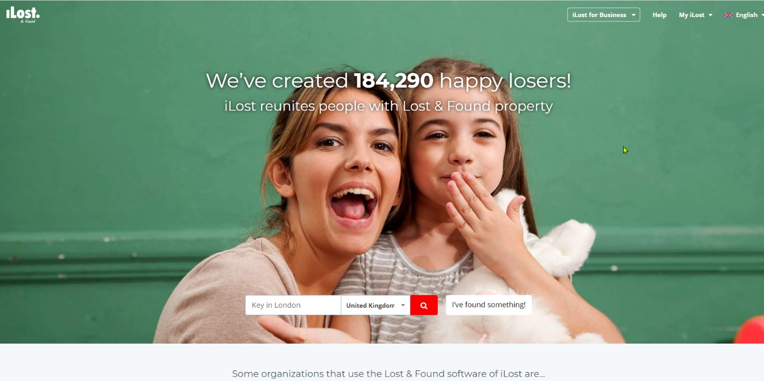

Figure .: ILost & found website.

(Bayard, 2015)

## Gaps in existing systems

Challenges facing the LFC website is that the website does not give you an alternative of finding your lost item if you do not have a device to download their application. On the login option they provide in the system it seems to not be working hence you cannot login and have a view of your subscription or the items they claim to have been lost making it very difficult for the user. They do not offer an option of individuals to report items that they have found. (karani, 2019)

Problems facing find my device web application cannot work if the internet connection of the device being traced has turned off or it lacks internet connectivity. The other thing that can hinder the application is that when the device that has been stolen being turned off by the thief. There is also the challenge of the device not having the location on it also prevents it from being tracked. If the device did not have a google account, it cannot work with find my device. There is also the problem of device formatting this will render the device untraceable hence it is not retrievable with the system. (Chris, 2019)

The problem facing Find My Lost system is that the system is currently only located in Italy and in England, it also allows a user to enter an award of the property they want from the property that they have discovered. This makes it unfair as someone might take this opportunity to be stealing things and claim that they located the stolen items hence taking the advantage of the system and victim. (Merlot, 2016)

The disadvantage of the system is that the system does not allow you to search for your lost item, the Limitation of the system only being located in limited number of countries and Kenya is exception in the list. It also does not give you the ability to communicate with the person who has possession on your device only giving him the option of delivering the item to the ILost offices. (Bayard, 2015)

## Conclusion

The develped system is solving the problem by creating a breif user friendly web-based system that is able to take user’s input. This has enabled the users to enter their stolen or lost items in which an individual can search a device identification number hence know if the item was lost or stolen. It has also enabled the people who find the lostor stolen device interract with the victims. The ability of the system to provide kenyas with a search report, which prevents kenyans from purchasing stolen or lost items.

## Conceptual Framework

In the figure below, a description is given on how the system works and the change of messages that take places from one user or point to another.

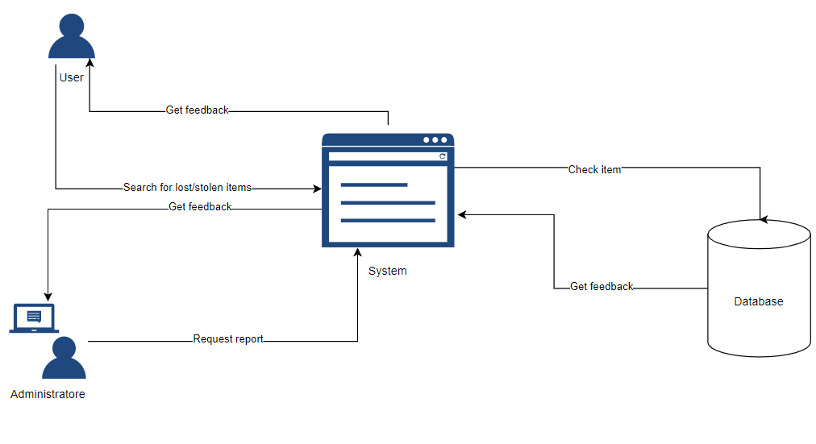

Figure .: Conceptual Framework

# System Development Methodology

## Introduction

This chapter highlights the methodology used in developing the system. The requirements of the system such as functional and non-functional requirements are also explained in order to understand the development of the system. What the system is delivering and the tools and techniques that enabled the delivery are discussed in detail in this chapter.

## Prototype Methodology

The developed system was developed using prototyping methodology. Prototyping is designing and building a scaled down but functional version of the desired system (Cegielski, 2010). As in the process the system is continually revised and there is a close collaboration between users and developers.

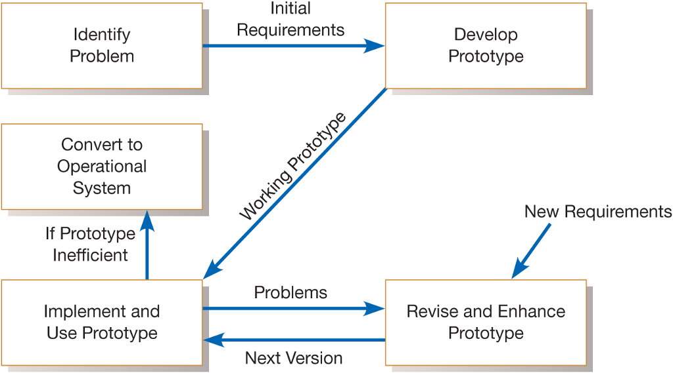

Figure . Prototype Methodology

(study, 2020)

### Identifying the Problem

At this stage, the identification of problems faced and means in which the problems were resolved. Objectives are then set with the general objective being to design, create and implement a system that will solve the current problems. Also, at this point the problems are arranged according to process of being solved.

### Develop Prototype

At this phase this is where we developed the system that solves the problem that have been stipulated when identifying the problem.

### Implement and Use Prototype

At this stage, its acts as the testing stage as in the process of one implementing the prototype to use you also correct the errors that are present on the prototype.

### Rehearse and Enhance Prototype

At this phase this is where one adds additional features and also maintains the prototype, also viewing if the system is up to standard and if the system has solved the stipulated problems.

### Convert to operational System

This is the final step that is releasing the system to users to uses.

## Justification of Methodology

The main reason for selecting the prototype methodology is because users get a say in the product early on, increasing user satisfaction. Hence, missing functionality and errors are detected easily and are able to be corrected before the final stage. It emphasizes team communication and flexible design practices which enables users have a better understanding of how the product works. Quicker user feedback provides a better idea of the user’s needs. (Lewis, 2019)

## Object Oriented Analysis and Design

Object-oriented analysis is a methodology used to examines system requirements from the perspective of classes and objects found in the specified domain. It focuses on what the system is supposed to do rather than how it will be done and looks at the behavior of the system independent of its domain. Object-oriented analysis looks at the real-world environment in which a system will operate, with this environment consisting of people and things interacting to create some result. The following process will be implemented to help in the successful implementation of the system. (Sauter, 1999)

### Functional Requirement

Functional requirements define the basic system behaviour. Essentially, they are what the system does or must not do and can be thought of in terms of how the system responds to inputs. Functional requirements usually define if/then behaviours and include calculations, data input, and business processes (AltexSoft, 2019).

1. **Authentication**

The Administration has the ability to create an account for a new user. The users is also able to create their own account in which all accounts are accessible through the impute of right credentials i.e., email/phone number and a password.

1. **Make report**

Incase of a lost or stolen item the User is able to fill a document that describes the item that was lost or stolen.

1. **Search report**

The search functionality enables the user to input a unique identifier of the item they are looking for e.g., EMEI number.

1. **Provide feedback.**

The administrator and users are allowed to give feedback on a lost item or stolen item through a live chat.

1. **View report**

Both users and administrators can view lost or stolen items.

1. **Print report**

The administrator can print the reports and filter the reports to what is required.

### Non-Functional Requirements

Nonfunctional Requirements define system attributes such as security, reliability, performance, maintainability, scalability, and usability. They serve as constraints or restrictions on the design of the system across the different backlogs. (Leffingwell, 2011).

1. **Reliability**

The system is trustable by all users. The system is available 24/07 with no down time.

1. **Portability**

The system is total portable as is available in both desktop, mobile and tablets. This has given the users the conveniences of using it anytime.

1. **Security**

The system has a centralized administrator who has the role of giving feedback, adding users, deleting records, adding stolen or lost items, and updating the system. The system needs one to sign up with his/her credential as serious matters are involved.

## Design

In Design this is where the system is depicted in form of various diagrams that illustrate the functionality. Use case diagram is a behavior diagram and visualizes the observable interactions between actors and the system under development. The diagram consists of the system, the related use cases and actors and relates these to each other (ursula meseberg, n.d.). Sequence diagram is used primarily to show the interactions between objects in the sequential order that those interactions occur (IBM Developer, n.d.). dataflow diagrams are used to graphically represent the flow of data in a business information system. Database schema is the skeleton structure that represents the logical view of the entire database. It defines how the data is organized and how the relations among them are associated. It formulates all the constraints that are to be applied on the data. (Tutorialspoint, 2006)

## System Development Tools and Techniques

These are the tools and methods used to develop the system. They include the programming and Markup languages used in preparing the system into a functional entity.

### HTML

This is a markup language that dictates the presentation of data on a webpage. HTML was used to create the webpages and user interfaces. The language was used to create the front-end of the system. The language was connected with a database that stores the inputted information and data.

### CSS

This programming language is also used on the front end of the system. It was used to decorating the html code so as to create a responsiveness and user-friendly system.

### PHP

Popular general-purpose scripting language. This programming language deals with the back end of the system. The language mainly used in connecting the front end that is html with the database.

### MySQL

It was used in creating database of the system. It is connected to the system by the aid of PHP.

### XAMPP

It is a simple, lightweight Apache distribution that makes it extremely easy for developers to create a local web server for testing and deployment purposes. It is used together with html in creating a local platform.

### JavaScript

This programing language helps in the system responsiveness and implementation of other features such as the search platform.

### STARUML

This is an application that was used in drawing diagrams.

## System Testing

Is a level of testing that validates the complete and fully integrated software product.

### Functional Testing

A functional testing was performed to guarantee that the web application’s functionalities are as per the specified requirements. Examples of functionality testing such as usability testing, system testing and unit testing shall be employed. Usability testing 24 represents the measure of how a system or software can be used by a user for example ease of user navigation within the system. On the other hand, system testing is used for the evaluation of whether the system is compliant to the specified requirements. Unit testing involves the testing of the individual modules to verify if they are functionally correct. (Tutorialspoint, 2019)

## Domain of execution

The developed system is a web application system. This is because a web system application is flexible and can be accessed with all devices and operating system hence reducing the limitation of a system.

## Milestones and Deliverables

The system maintains its security by hashing the users’ passwords it also automatically logs the user out when they are not using the system. The password is only visible to the user.

### Administrator module

In this module the administrator is able to add lost or stolen items, add report feedback, search for a report, view a report, permanently delete a report, add a new user, and delete a user.

### User module

This module enables users to add a new report, view a report, search a report, mute their report, unmute their report and finally provide feedback through chat on a lost or stolen item.

# System Analysis and Design Description

## Introduction

System analysis is the process of gathering and interpreting facts, diagnosing

problem and the information to recommend improvement on the system. The

system analyst play the role of the interrogator and the dwells deep into working of

the present system identified. The output form the system are traced to the various

proces

System analysis is the process of gathering and interpreting facts, diagnosing

problem and the information to recommend improvement on the system. The

system analyst play the role of the interrogator and the dwells deep into working of

the present system identified. The output form the system are traced to the various

proces

System analysis is the process of gathering and interpreting facts, diagnosing problem and the information to recommend improvement on the system. The system analyst plays the role of the interrogator and the dwells deep into working of the present system identified. The output forms the system are traced to the various process. (wecomputing, 2020)

## Requirements Gathering

Below are the tools that were used to carry out the research.

### Data collection

This is mixed methods research where both qualitative and quantitative methods of data collection are used to study the variables related to the system. Given this focus, literature reviews, questionnaires and interviews were used in the collection of data. According to Van der Merwe (1996:290), in theoretical studies the researcher produces his/her evidence to support arguments from existing facts or information.

### Literature review

This study focuses on online platforms that have been developed to modernize travelling procedures. For this purpose, an extensive and relevant literature review was conducted to provide a theoretical foundation for the research project. The literature review provided scientific explanations for the research questions that enabled the verification of the researcher’s findings and to compare with other scholars in the field. (sagepub, 2006)

### Questionnaires

A questionnaire is a form containing a set of questions, especially addressed to a statistically significant number of subjects, and is a way of gathering information for a survey. It is used to collect statistical information or opinions about people. The Oxford Advanced Learner’s Dictionary (1997:952) defines a questionnaire as a written or printed list of questions to be answered by a number of people, especially as part of a survey. For the purpose of this study, the questionnaire formed the second data collection method. For the purpose of this research a set of open and close ended questions were drafted for the purpose of getting feedback from respondents.

### Interviews

Seale, Giampetro, Gubrium and Silverman (2004) define an interview as a social encounter where speakers collaborate in producing retrospective and prospective accounts or versions of their past or future actions, experiences, feelings and thoughts. Two types of interviews were used in this study, namely focus group interviews and structured interviews.

### Focus Group Interviews

Focus group interviews were conducted first, followed by the one-on-one interviews. The purpose of this exercise was to assist the researcher in formulating relevant questions for the one-on-one interviews. (statisticssolutions, 2020)

### Structured Interviews

Structured interviews were conducted with affected users who were conveniently sampled, and their responses were recorded with their permission. This induced first-hand information from the interviewed with regard to their experiences, challenges, technical issues and opinions. An interview schedule was compiled in which the interview questions were outlined. The questions were mostly open ended, making it possible for the interviewer to add new questions during the interviewing process, depending on the responses of the participants.

## System Requirements

System requirements is a statement that identifies the functionality that is needed by a system in order to satisfy the customer’s requirements. System requirements are a broad and also narrow subject that could be implemented to many items. Whether discussing the system requirements for certain computers, software, or the business processes from a broad view point. Also, taking it down to the exact hardware or coding that runs the software. System requirements are the most effective way of meeting the user needs and reducing the cost of implementation. System requirements could cause a company to save a lot of money and time, and also can cause a company to waste money and time. They are the first and foremost important part of any project, because if the system requirements are not fulfilled, then the project is not complete. (Siedle, 2015)

### Functional Requirements

|  |  |
| --- | --- |
| FR1 | The system should allow a finder or owner to sign up. |
| FR2 | The system should allow a finder or owner to sign in. |
| FR3 | The system should allow the owner to view the reported found items. |
| FR4 | The system should allow the Finder to view reported lost items. |
| FR5 | The system should allow the users (owner and finder) to fill in the relevant forms. |
| FR6 | The system should allow the users to update their profile. |
| FR7 | The system should allow the users to update their reports. |
| FR8 | The system should allow the users to temporarily delete their reports. |
| FR9 | The system should allow the admin to sign in. |
| FR10 | The system should allow the admin to add records both lost or found. |
| FR11 | The system should allow the admin to sign up a user with a temporary password. |
| FR12 | The System should allow the admin to view both lost and found items. |
| FR13 | The system should allow the admin to view a report view of Users |
| FR14 | The system should allow the admin to know who is verified of not |
| FR15 | The system should allow the admin to print a copy of the reports. |
| FR16 | The system should allow the admin to download the forms. |
| FR17 | The system should allow the Finder and owner to have a conversation through a chatbox |

Functional requirement is a description of the service that the software must offer. It describes a software system or its component. A function is nothing but inputs to the software system, its behavior, and outputs. It can be a calculation, data manipulation, business process, user interaction, or any other specific functionality which defines what function a system is likely to perform (Martin, 2021)

Table .: Functional Requirements

### Non-Functional Requirements

Simply said, a non-functional requirement is a specification that describes the system’s operation capabilities and constraints that enhance its functionality. These may be speed, security, reliability, etc. (altexsoft, 2019)

|  |  |  |
| --- | --- | --- |
| **IDs** | **Category** | **Description** |
| NFR1 | Usability | The system should allow users to navigate the user interface with ease. |
| NFR2 | Reliability | The system should provide security for users and their information they store. |
| NFR3 | Performance | The system should be fast in accessing and processing of commands. |
| NFR4 | Supportability | The system should be accessible no matter the device used, or search engine used to access the system. |
| NFR5 | Recovery | The System should only allow temporary deletion of information incase recovery is needed |

Table .:Non-Functional Requirements

## System Architecture

The system architecture, a diagram that illustrates the interaction between the system components is as shown.

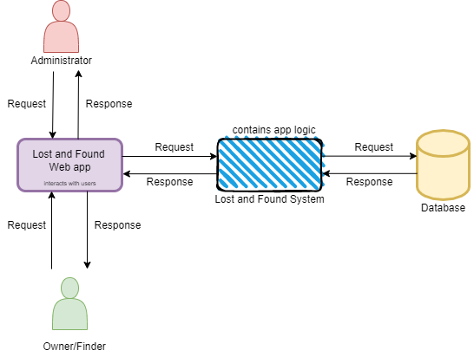

Figure .: System Architecture

## Analysis

System analysis is conducted for the purpose of studying a system or its parts in order to identify its objectives. It is a problem-solving technique that improves the system and ensures that all the components of the system work efficiently to accomplish their purpose. It has been represented with a use case diagram. (Swarna, 2006)

## Design

It is a process of planning a new business system or replacing an existing system by defining its components or modules to satisfy the specific requirements. Before planning, you need to understand the old system thoroughly and determine how computers can best be used in order to operate efficiently. They include: a use-case diagram, a sequence diagram, a class diagram, an entity relationship diagram, and a database schema. (Swarna, 2006)

### Use case diagram

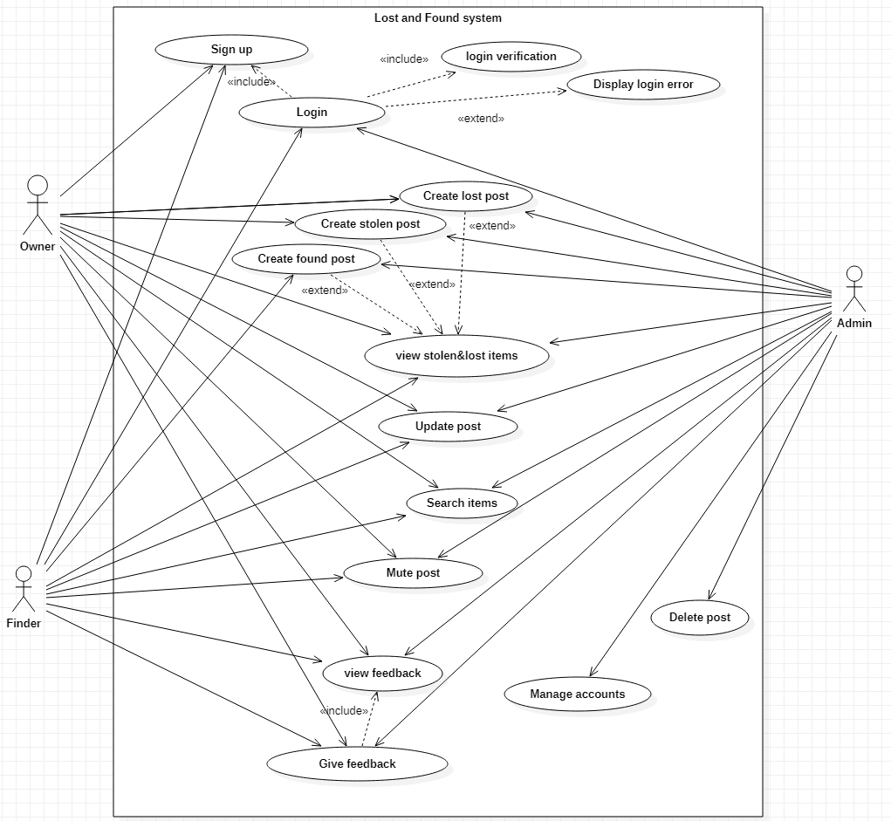

Figure .: The use case diagram

The use-case diagram illustrates the requirements of the various users in the Lost and Found system. The requirements are represented by the use cases and the users are represented by the actors, admin, owner, and the Finder.

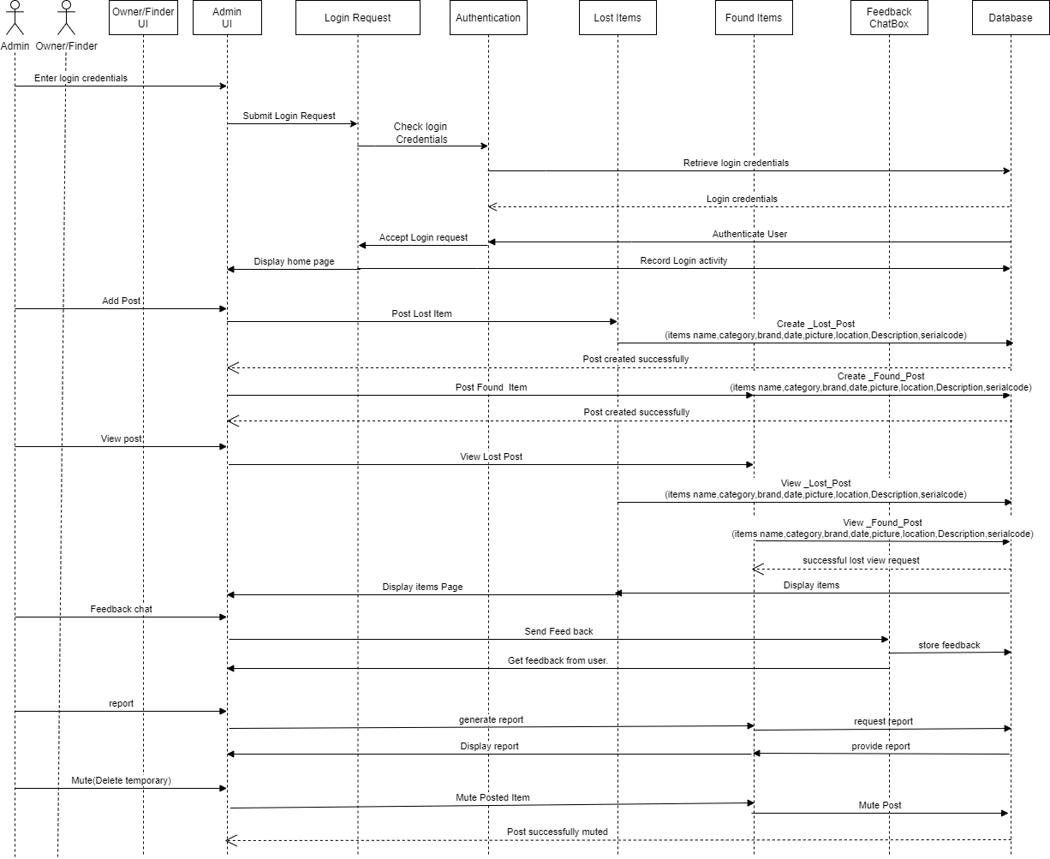

Figure .: Sequence Diagram

### Class Diagram

The class diagram above depicts the classes of controllers and models of the web-based application system accessed by the admin, finder, and owner.

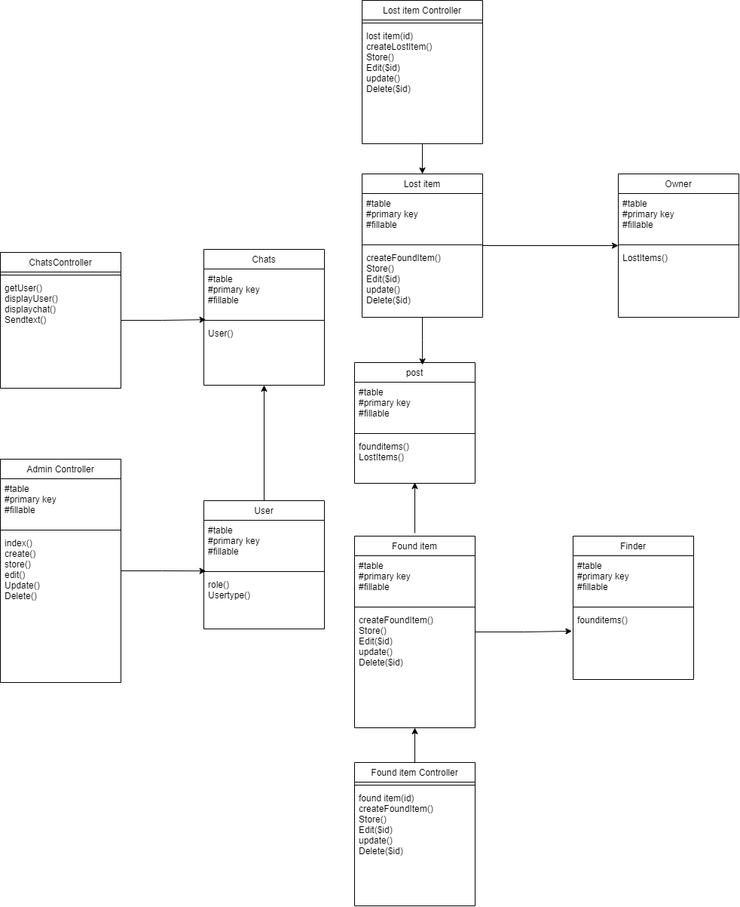

Figure .: Class Diagram

### Entity Relation Diagram

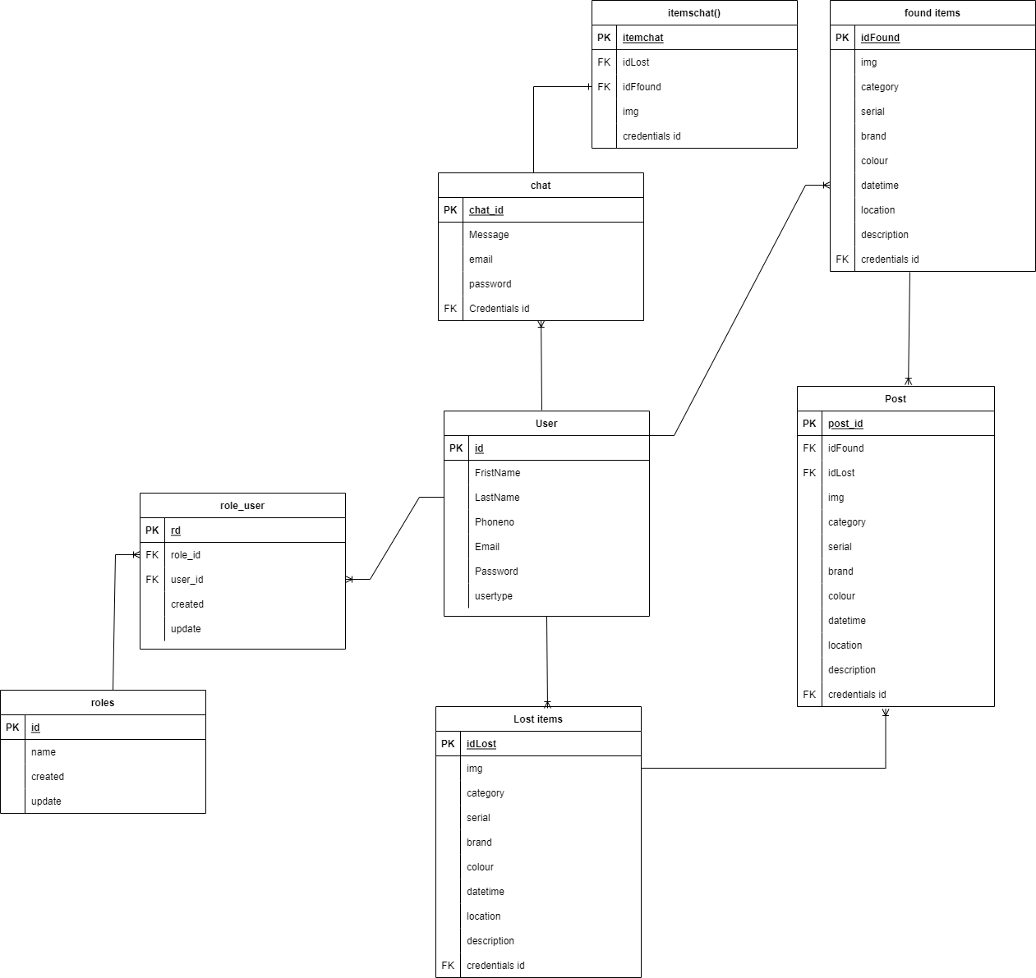

Figure .:Entity relation diagram

### Database schema

Figure .: Database Schema

# System Implementation and Testing

## Introduction

For the purpose of the system construction this chapter seeks to cover more on what the system entails and what is the purpose of various sections of the system. It will also focus on the system testing and where the different sections of the system have truly succeeded or not. This chapter aims at detecting system failures so that defects can be discovered before the system is fully implemented in the society. We must implement the system to know if it truly works as expected and test on whether it can handle a task no matter how it comes to the system.

## System Implementation

The process in which the system was built in regard to the system analysis and design methodology. The initial start was collection of data where we used observation and identification if figuring out the different types of users that are in the system. The main actor that was first identified in the system was the Owner, The finder, and The Admin. The Next stage of identification on the system was identifying the different types of modules that are in the system. The most important activity for the owner and finder in the system is being able to upload lost or found item into the system, view items that have been posted as lost or found in the system. Update the report that has been created of a lost or found item in the system. The admin will have an overview of what is happening in the system by being able to see what has been posted and who has posted the item. The construction of the system and development was done by HTML, PHP and JavaScript. Business requirements were earlier identified and were structured into the system. Using the proposed system development methodology, it proved easy and more applicable to develop the system by prototyping and developing each module at a time. On completion of the different module development, they were later linked to come up with the system as a whole. The linking of the pages is important as it maintains the logical operation of the system. To begin with, there was the development of the CRUD functionality in that there was the division of the different aspects of CRUD that was to be done by the different actors of the system. For the lost and found system it needed update, view, edit, delete and create.

## System testing

System testing is a level of testing that validates the complete and fully integrated software product. The purpose of a system test is to evaluate the end-to-end system specifications. Usually, the software is only one element of a larger computer-based system. Ultimately, the software is interfaced with other software/hardware systems. System Testing is actually a series of different tests whose sole purpose is to exercise the full computer-based system. (Martin, 2021). This section also aims to detecting system failures and the detection of defects that can be discovered before the system is fully implemented into its intended environment.

### Functionality testing

The lost and found system satisfied all the specific requirements except the geographic scope automate in which it allowed users to have free will in entering the location they lost or found an item.

The requirements that were satisfied include admin, owner, finder being able to log in, being able to create lost or found report, edit the report each individual was able to create, view the lost or found items reports, being able to update each individual’s report, view their profile, they can be able to temporary delete a report, have conversation with the intended individual through a chat box. Other requirements satisfied were admin being able to auto generate a report, admin being able to filter a report, being able to print a report, being able to create an account for a user with a temporary password. Being able to view that status of each individual.

### Usability testing

Navigating and interacting with the system it is smooth as the pages are responsive and they all give feedback once interacted with.

The system has a notification mechanism that allows for interactivity with users upon performing transactions within the system like logging in, inserting, updating and deleting data. The notification messages entail success messages that are displayed on the view upon a successful transaction and error messages when transactions fail to complete successfully.

### Unit testing

The components of the lost and found system functioned as per the specified requirements when working independently of each other.

# Discussion, conclusion and recommendation

## Introduction

The aim of this chapter is to summarize the discussion on the objectives mentioned in chapter 1 above, and to provide conclusions related to the discussion on each of the objectives. Furthermore, it seeks to delve into the technical aspects that will ensure the proper working of the system. There will also be the coverage on what the system was not able to achieve and make recommendations on future works that can be achieved by similar systems that aim to solving the same problem.

## Discussion

As mentioned before this section will entail an analysis of the developed system and scrutinization of the system as well. The developed system as of its completion can be used by the two main actors of the system in this case having two modules of the system. That is the Owner and finder module and the admin module who have their different tabs and functionalities depending on who is who is accessing the system. The Owner and the Finder are able to log in to the system once they have signed up into the system and have verified their verification code. The owner and finder are able to view all lost items, and all found items. In which it helps in identification of owners or finders that have the item that is being searched. The owner is also able to text the finder informing him that about the item that they claim is their hence making verification if it is indeed theirs before setting up location at a secure place such as a police station or a chief camps area. The admin is able to monitor the posting and deletion of items hence he is able to also help in posting lost items. He can also generate a report that are used as a backup in case of system failure. The admin can also add a user into the system with a temporary password before passing the credentials to the users and requesting them to change the information. The user can access their profile and edit all information where relevant which also reflects to the admin panel. The users are all able to search and filter the posted items hence getting the actual items they are looking for.

## Conclusion

In the process of losing or finding something that was lost, it was found out that is quite hard to trace the owner of the item who lost the item or who found the lost item. This was evident was when we did a survey most people said that recovering their lost items was actually close to impossible as you had no way of knowing who found what you are looking for.

The system was good in addressing the problem of locating the owner and also preventing of handling of stolen property as one could see what was linked with the item, they found through the description that was stated in the system. Hence solving the lost and found problem and other problems that relate to

## Recommendation

For this system it is recommended to the individuals who have lost an item or who have found a lost item. It is also highly recommended towards people dealing in the selling of secondhand product as it will give a plat form to look if the product, they are purchasing has a record over it. This is possible as it has an integrated chat that helps the users to keep in tach and give feedback here necessary.

## Future Work

Despite it being a functioning system, it is has not been able to tackle all problems around lost and found items. Therefore, the future work to enhance the research can entail the research and development of a lost and found system that enables for offline methods of a lost or found item to the database without internet connectivity. Such method can involve SMS. There is also the location of meetup is also a factor that is going to get looked at hence establishing safe points of meet up or other means of getting your item without meeting the individual who actually posed your item.

Reference

(n.d.). Retrieved from https://www.w3computing.com/systemsanalysis/roles-systems-analyst/

altexsoft. (2019, 11 21). Retrieved from altexsoft: https://www.altexsoft.com/blog/non-functional-requirements/

AltexSoft. (2019, 8 24). *qracorp*. Retrieved from Guides & Checklists, Requirement Engineering: https://qracorp.com/functional-vs-non-functional-requirements/

Bayard, N. (2015, 4 13). *ILost*. Retrieved from ILost & found: https://ilost.co/

Bolluyt, J. (2016, 6 22). *Warning! 9 Signs That You’re Buying Stolen Electronics*. Retrieved from cheatsheet: https://www.cheatsheet.com/gear-style/warning-signs-youre-buying-stolen-electronics.html/

Casper. (2020, 3 14). *FaundIt*. Retrieved from faund it: https://db.faundit.com/

Cegielski, R. &. (2010). *Prototyping versus SDLC*. Retrieved from prime-essay: https://prime-essay.net/samples/Research/prototyping-versus-sdlc-essay.html#:~:text=Prototyping%20is%20defined%20as%20designing,version%20of%20the%20desired%20system.&text=Rainer%20%26%20Cegielski%20(2010)%20noted,iterations%20based%20on%20user's%20feedba

Chris, W. (2019, 8 17). *Find my device* . Retrieved from https://www.google.com/android/find

Hornyak, T. (2020, 4). *japanstation*. Retrieved from japan station guid: https://www.japanstation.com/complete-guide-to-lost-and-found-in-japan/

IBM Developer. (n.d.). *IBM*. Retrieved from IBM: https://developer.ibm.com/technologies/web-development/articles/the-sequence-diagram/

Kamau, J. (2018, 4 8). *Kenya Law*. Retrieved from caselaw: http://kenyalaw.org/caselaw/cases/view/149346

karani, l. (2019, 3 10). *lost and found*. Retrieved from lost and found: https://lostandfounddc.co.ke/

kenya-police. (2018). *national police*. Retrieved from crime-statistics: https://www.nationalpolice.go.ke/crime-statistics.html#

Lakshman. (2018, 8 9). *Prototype model, sdlc*. Retrieved from Learning programing by lucky sir: http://learnprogramingbyluckysir.blogspot.com/2018/08/what-is-prototype-model-in-software.html

Leffingwell, D. a. (2011). *scale dagile framework*. Retrieved from scale dagile framework: https://www.scaledagileframework.com/nonfunctional-requirements/

Lewis, S. (2019, 9). *Prototyping Model*. Retrieved from SearchCIO: https://searchcio.techtarget.com/definition/Prototyping-Model

Martin, M. (2021, 12 18). Retrieved from Guru99: https://www.guru99.com/functional-requirement-specification-example.html

Merlot, D. (2016, 2 12). *Find My Lost*. Retrieved from find my lost: https://www.findmylost.it/en

sagepub. (2006, 7 12). *sagepub*. Retrieved from https://www.sagepub.com/sites/default/files/upm-binaries/29986_Chapter3.pdf

SAS, T. (2020, 10 11). *troov*. Retrieved from Troo: https://www.troov.com/en

Sauter, T. T. (1999, 11 29). *OBJECT-ORIENTED ANALYSIS*. Retrieved from umsl: https://www.umsl.edu/~sauterv/analysis/ooa.html

Siedle, J. (2015, 6). *System Requirements*. Retrieved from umsl: https://www.umsl.edu/~sauterv/analysis/F2015/System%20Requirements.html.htm

statisticssolutions. (2020, 7 24). *www.statisticssolutions.com*. Retrieved from statisticssolutions: https://www.statisticssolutions.com/what-are-focus-group-interviews-and-why-should-i-conduct-them/

Story, G. B. (Director). (2020). *How Tokyo’s Massive Lost & Found Works* [Motion Picture].

study, C. (2020, 7 27). *-consider-system-produces-budget-reports-department-work-alternatively-consider*. Retrieved from chegg study: https://www.chegg.com/homework-help/questions-and-answers/1-consider-system-produces-budget-reports-department-work-alternatively-consider-registrat-q24038489#question-transcript

Sutton, M. (2020, 6). *SUPPLY BY THEFT: Does the Market for Second-hand Goods Play a Role in Keeping Crime Figures High?* Retrieved from jstro: https://www.jstor.org/stable/23637892

Swarna, G. (2006). *System Analysis and Design - Overview*. Retrieved from tutorialspoint: https://www.tutorialspoint.com/system_analysis_and_design/system_analysis_and_design_overview.htm

Tutorialspoint. (2006). *Tutorials point*. Retrieved from https://www.tutorialspoint.com/dbms/dbms_data_schemas.htm

Tutorialspoint. (2019). *Black box testing*. Retrieved from tutorialspoint.com: https://www.tutorialspoint.com/software_testing_dictionary/black_box_testing.htm

ursula meseberg, b. n. (n.d.). *microtool*. Retrieved from micro tool making IT better: https://www.microtool.de/en/knowledge-base/what-is-a-use-case-diagram/

wecomputing. (2020, 12 24). *system analysis*. Retrieved from w3computing: https://www.w3computing.com/systemsanalysis/roles-systems-analyst/

Appendix

Appendix A: Gantt chart

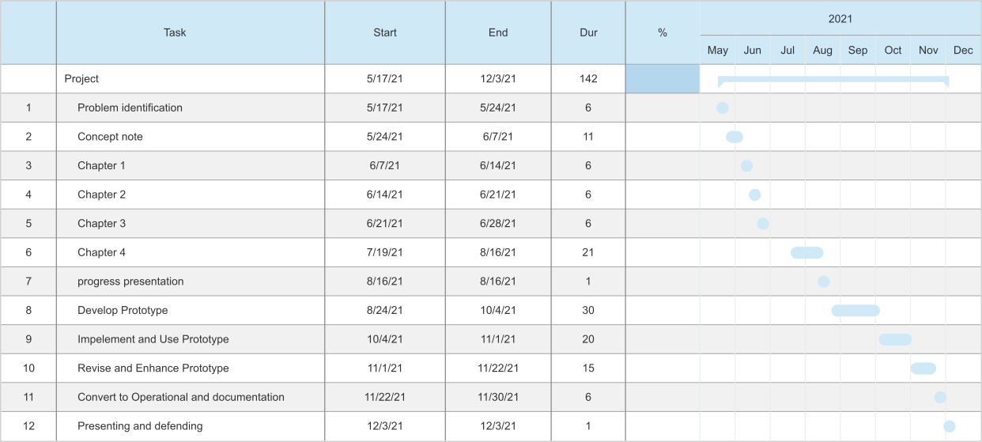

Figure .: Gantt chart

Appendix B: Data collection

1. Have you ever lost an item?

* Yes
* No

1. Have you ever found an item?

* Yes
* No

1. What measures do you take when you find a lost item?
2. What measure do you take lose an item?
3. Were you able to locate the item you lost? If yes, how did you locate your item?
4. Were you able to locate the owner of the item you found? If yes how.
5. Would you use an online application as a means of finding your item in future?

* Yes
* No, why?
* Maybe, why?

1. Would you use an online application as a means of finding an owner of a lost item in future?

* Yes
* No, why?
* Maybe, why?

1. Would you consider testing an online lost and found system?

* Yes
* No, why?
* Maybe, why?

Appendix C: Interesting Code

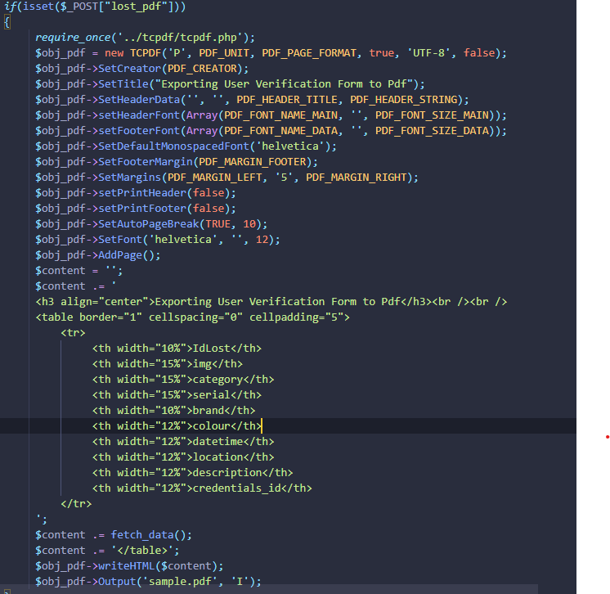

Figure .: Pdf converter script

The above image shows a pdf converter script which converts a HTML table code into a pdf.

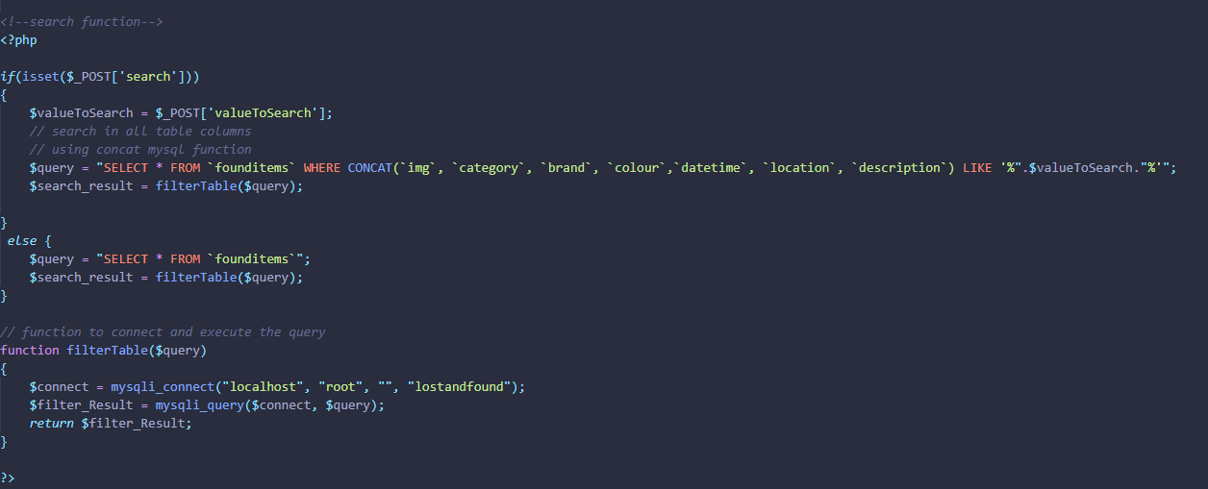

Figure .:Search and filter script

The image above shows a search and filter script that enables an individual to filter the lost or found item view.

Appendix D: User Manual

Under user interface is where the system interfaces are going to be displayed and what is happening under each interface is going to be explained.

Figure .:Signup Form

The user needs to initially sign in through the form displayed above with the correct details.

Figure .:Login Form

The users the proceed to login in which automatically takes the user to the intended page depending on the user type.

Figure .: Landing page

Owner and Finder landing page once successfully login into the system

Figure .:Admin Panel

The image above shows the admin panel and displays the different functionalities under the admin.

Figure .:Found Items Form

The image displays the found item form which you are required to fill it correctly with accurate information.

Figure .:Lost items

Lost item form is displayed above.

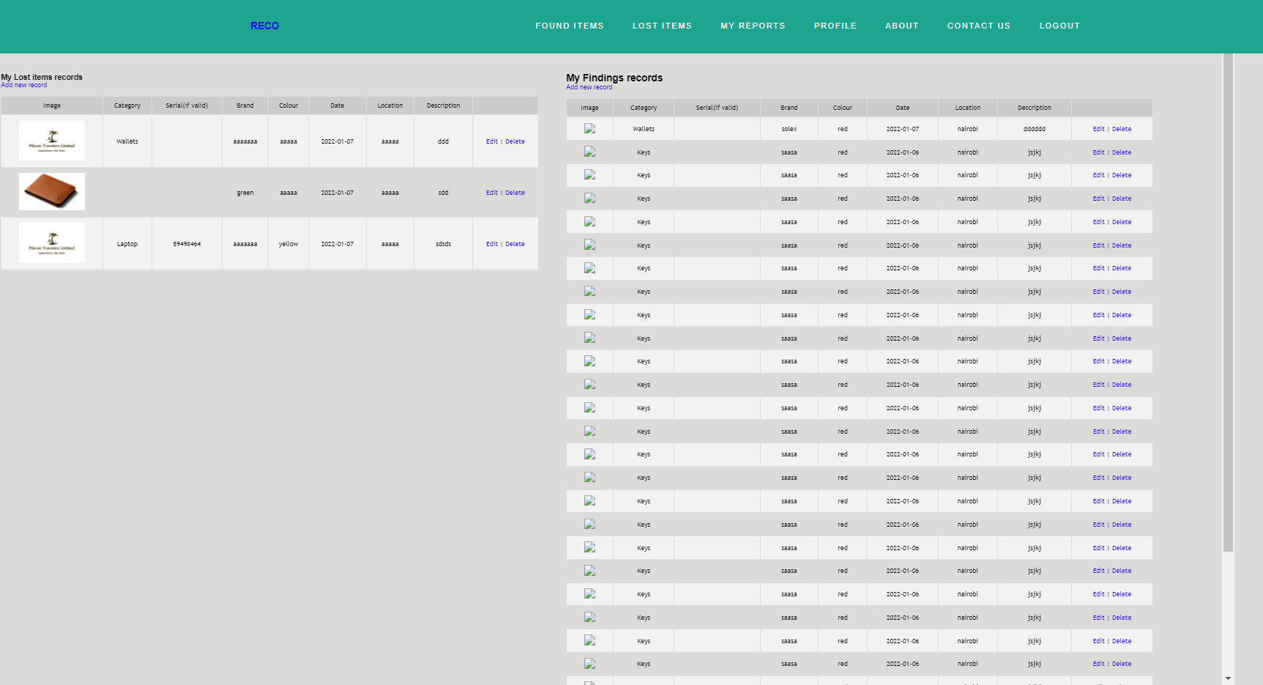

Figure .:Display of all lost and found items

Figure .:PDF converter of reports

Admin report making portal. Converts HTML to PDF forms.

Figure .:Feedback(chat box)

This is the place where you communicate with the owner or finder of the item.

